COUNTRY PROFILE
SRI LANKA

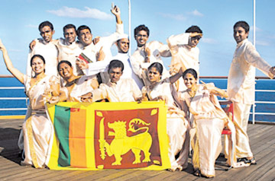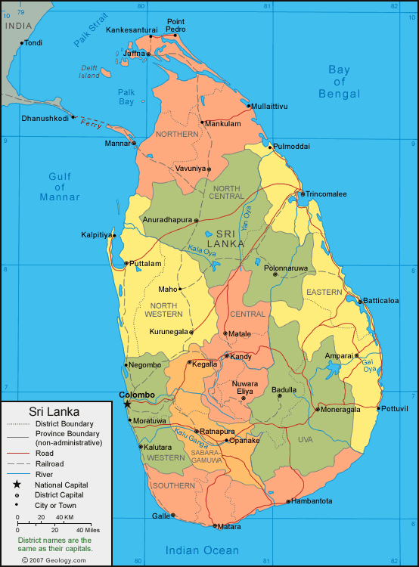

Introduction
Situated off the southern tip of India, Sri Lanka is an island nation, home to a diverse population amounting to 20.27 million. With a land area of 62.7 square kilometers the country boasts of an exotic mixture of languages, cultures and religions with an abundance of tourist attractions like the sunny beaches, glorious ancient cities, salubrious hill country, beautiful flora & fauna, traditional arts and crafts and colourful festivals.
The administrative capital is Sri Jayawardenepura, Kotte while the commercial hub is the city of Colombo which is a fast developing center of Business, Education and Health.

Adolescent statistics
The adolescent group make up 19.7% of the population with a male to female ratio close to one. 91.4% complete primary education while up to 67% proceed until completion of secondary education. The mean age of marriage among females is 23. 5 years.

Issues of adolescent health
Among the issues pertaining to adolescent health use of tobacco, alcohol and other addictive substances take importance and the current prevalence of smoking amount to 6% among males and 1% among females.
Poor knowledge among school going and out of school adolescents on reproductive health issues is a major issue with only 57% being aware of the existence of sexually transmitted diseases. A fair proportion of 14 – 19 year olds are sexually active with a male preponderance. Sexual abuse among adolescents is another issue with up to 14% reporting abuse at some point of their lives. Teenage pregnancies amount to 6.1 %. Suicides were recorded in 5.8% of the adolescents and accidents and injuries were also seen.
Nutritional deficiencies like PEM, iron and iodine are also seen while non-communicable diseases are an emerging problem. Also up to 4% also reported serious problems with family members affecting mental wellbeing.

Action plan for 2015

Combating substance abuse and promotion of mental health

- Providing life skills training
- Development of a teen health website

Nutrition and physical fitness
- Weekly iron and folate supplementation
- Conduct of School Medical Inspections with more emphasize on mental health
- Continue life skills Training of Trainers programme
- Mid day meal programme
- Pilot programme of issuing physical fitness certificate to students who participate in sports
- Developing a midwife health care package for adolescents
- Organizing sports events to convey health and nutrition messages among adolescents
- Increasing age limit for paediatric care up to 16 years
- Development of management protocols for common illnesses among adolescents

Adolescent Sexual and Reproductive health

- Development of education materials for teenagers and parents on ASRH
- Advocacy to members of Judiciary and Law enforcing authorities on ASRH laws
- Advocacy programs for identified legal gaps regarding SRH services provided for adolescents
- Adolescent health camps for grade 10 students and teachers
- Development of a distant education packages for teachers on Sexual and Reproductive health
- Involvement of Sri Lanka College of Obstetricians and Gynaecologists in teacher and student training in ASRH
- Effort to include SRH component in the activities of boy scouts, girl guides and among youth in the estate sector.
- Development of a glossary on SRH in sign language for those with hearing ang vision impairments
- Development of a teen website

Youth empowerment
- Improving existing youth clubs
- Increasing youth involvement in civil society through the Youth Parliament Programme.
- Vocational training programs
- Conducting programs to empower youth involving parents/ relationships at the community level with the concept of “Happy Family”
- Implementation of youth policy

